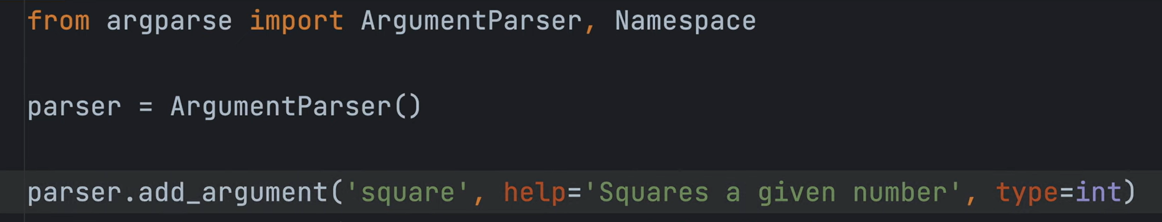

Help – gives info

Type – says what type the input is going to be taken as



Basically stores true in the said argument



To create a Namespace which would have all the arguments values



Provides helpful info about stuff



Can give default values

counts the number of occurances of that particular character, returns an integer when done args.verbose

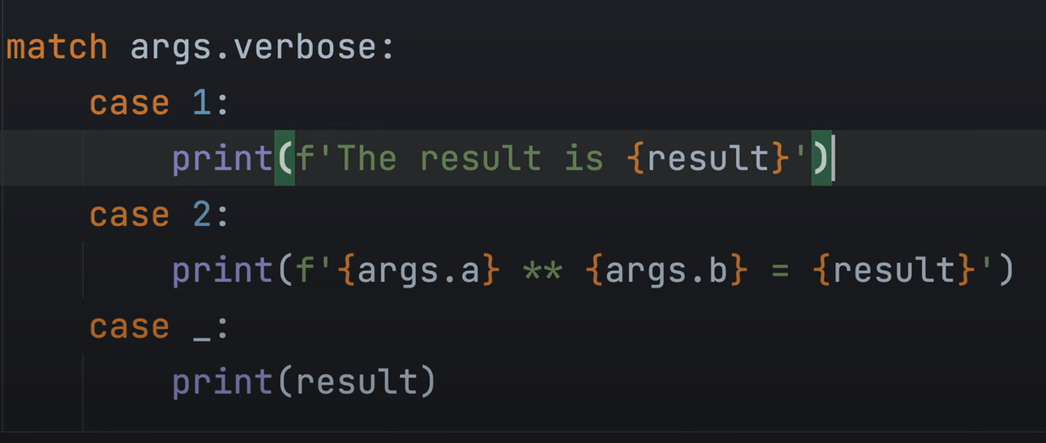

Switch statement in python, case _ is the default



This gets displayed when -h is called at the top of the page



Creates a group from which you can have only one variable on the command line interface

And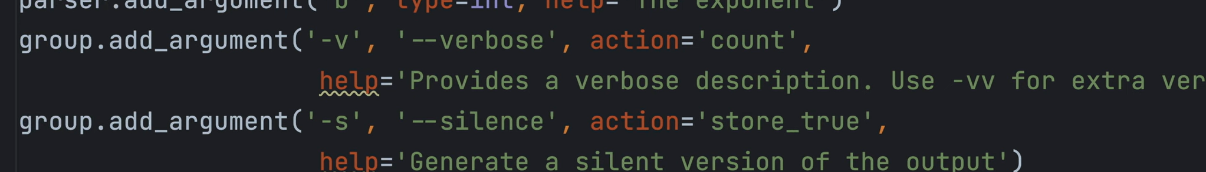

You’ll add it to a group instead of a parser